Nodeserver/

├── server.js # Main entry point for the Node.js server

├── authRoutes.js # Handles authentication-related routes

├── users.js # Simulated user database

├── jwtUtils.js # Handles JWT generation and verification

├── .env # Environment variables

├── package.json # Dependencies and scripts

Postman Testing for /Authorize ::

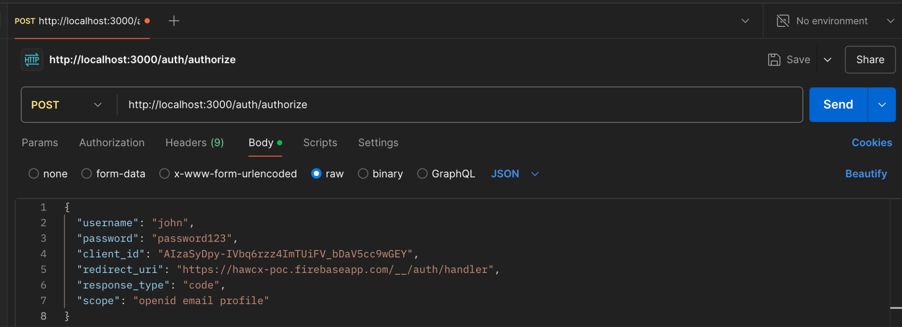

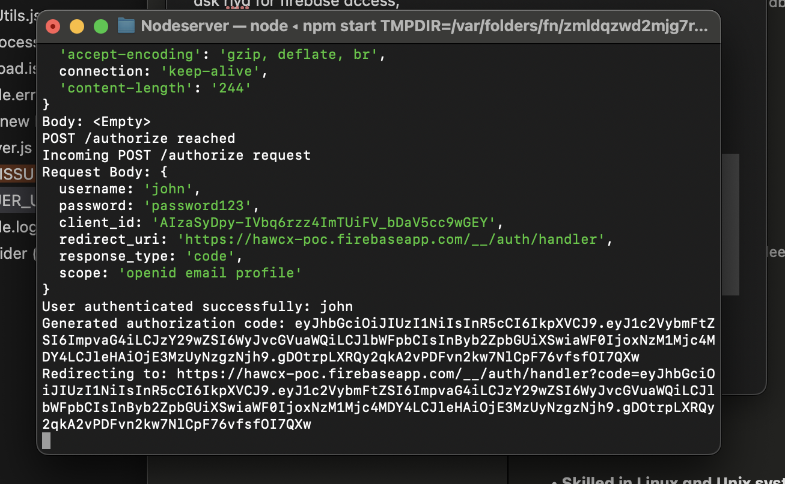

Postman testing for \token

